Question 1:
A data engineering team wants to ingest data from several SaaS and operational systems into Databricks with minimal custom code. They want a managed ingestion experience and prefer to avoid building notebook-based extraction logic where possible.
Which two statements best describe when Lakeflow Connect is an appropriate choice
- It is appropriate when the team wants to ingest from supported sources while keeping governance aligned with Databricks-native ingestion workflows.
- It is the recommended feature for querying an external PostgreSQL database in place without ingesting it into Databricks.
- It is required for reading JSON files from cloud object storage with schema drift, even when Auto Loader already supports the use case.
- It is appropriate when the team wants managed connectors for supported external sources instead of hand-built extraction code.
- It is the default solution for implementing custom REST pagination logic against unsupported APIs.
------------------------------------------------------------------------------------------------------------------
Overall explanation:
Lakeflow Connect natively integrates with Unity Catalog, Databricks' built-in governance and security layer. Because it is a native tool, security permissions, data lineage, auditing, and access controls automatically apply to the ingested data out-of-the-box, ensuring governance remains unified with the rest of the Databricks platform.
The primary value proposition of Lakeflow Connect is providing fully-managed, out-of-the-box connectors (for tools like Salesforce, SQL Server, Jira, ServiceNow, HubSpot, etc.). It completely removes the need for data engineers to write complex API pagination, handle rate limits, or script hand-built notebook code to land data into the lakehouse.
------------------------------------------------------------------------------------------------------------------
Documentation:
Managed connectors in Lakeflow Connect
What is Lakeflow Connect?
Lakeflow Connect

Correct Answer (1,4)

Question 2:
A data engineer is tuning a Spark SQL join between a very large fact table and a very small dimension table. The current physical plan uses a sort-merge join, causing heavy shuffling. The engineer wants Spark to replicate the small table to executors so the large table does not need to be shuffled for the join.
Which function should be applied to the small table to force this behavior?
- repartition(small_table)
- broadcast(small_table)
- coalesce(small_table)
- cache(small_table)
------------------------------------------------------------------------------------------------------------------------------------
Overall explanation
Broadcast Hash Join (BHJ) is a performance optimization technique in distributed computing.
- Standard Join (Shuffle): Both Table A and Table B are sorted and exchanged across the network so that matching keys end up on the same node. This is slow for large data.
- Broadcast Join: Table B (Small) is copied to all nodes. Table A (Large) stays put. The join happens locally.
Spark has a configuration spark.sql.autoBroadcastJoinThreshold (default 10MB). If a table is smaller than this, Spark automatically broadcasts it. However, in this scenario, the table might be slightly larger than the threshold, or the optimizer's statistics might be missing. Explicitly using the broadcast() function overrides the estimates and forces the optimization.
------------------------------------------------------------------------------------------------------------------------------------
Documentation Reference:
pyspark.sql.functions.broadcast

Correct Anwser: (2)

Question 3:
A data engineer manages a Lakeflow Spark Declarative Pipeline that ingests a batch of financial reports. These reports are uploaded to cloud storage exactly once per day at 02:00 UTC. Currently, the pipeline is configured in "Continuous" mode. The engineer observes that the cluster remains active and billable 24/7, even though the data processing finishes in just 15 minutes. Management has requested a configuration change to minimize compute costs while ensuring the daily file is processed completely.
The engineer is reviewing the file arrival history:
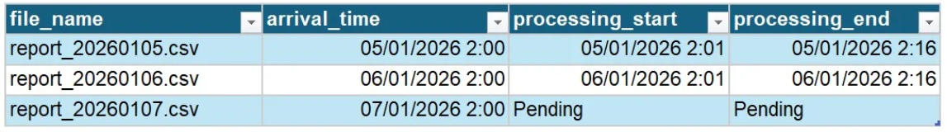
Which pipeline execution mode should the engineer select to meet the cost-reduction requirement?
- Auto Scaling
- Continuous
- Triggered
- Serverless
------------------------------------------------------------------------------------------------------------------------------------
Overall explanation:
In Databricks Lakeflow Spark Declarative Pipelines (and standard Structured Streaming), there are two primary execution modes that dictate how the compute resources interact with the data stream:
- Continuous Execution: The compute resources stay up 24/7. The system constantly polls the source or sets up a long-running connection to process events as soon as they arrive.
- Triggered Execution: The system starts, processes "what is currently available" (the delta between the last checkpoint and now), and then shuts down.
While Serverless compute eliminates the need to manage infrastructure and can start up faster, selecting Serverless alone does not determine when the pipeline stops. If a Serverless pipeline is set to "Continuous" mode, it will still incur charges for maintaining the active state to listen for incoming data.
------------------------------------------------------------------------------------------------------------------------------------
Documentation Reference:
Pipelines Mode

Correct Answer: (3)
Question 4:
A platform admin wants to build a chargeback dashboard that aggregates DBUs consumed per job and per cluster, bucketed hourly, across the entire account. They want to query this data directly in SQL using Unity Catalog system tables.
Which system table contains the detailed billable usage records needed for this analysis?
- system.billing.usage
- system.access.audit
- system.query.history
- system.compute.node_types
------------------------------------------------------------------------------------------------------------------------------------
Overall explanation:
Observability in Databricks covers three pillars managed by System Tables:
- Performance: system.query.history (Mirror Q75). "Why is it slow?"
- Cost: system.billing.usage (This Question). "Who is spending money?"
- Audit: system.access.audit. "Who logged in?"
Without System Tables, cost analysis is a black box. You get a bill for "$50,000" at the end of the month. With system.billing.usage, you can run:
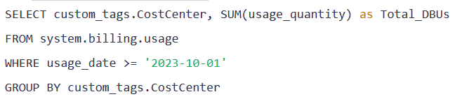
------------------------------------------------------------------------------------------------------------------------------------
Documentation:
- Databricks - Billing Usage

Correct Answer: (1)

Question 5:
An e-commerce platform runs Lakeflow Spark Declarative Pipelines under Unity Catalog and monitors them in the Jobs UI. They run:
- Bronze → Silver as a nightly full refresh
- Silver → Gold incrementally every hour
Recent failures occurred because a new run starts before the previous one finishes.
Which approach best prevents overlapping executions?
- Increase the cluster size so each run finishes faster
- Enable "Allow concurrent runs" in pipeline settings
- Set max_concurrent_runs = 0
- Configure the job to allow only 1 concurrent run so later runs queue instead of overlapping.
------------------------------------------------------------------------------------------------------------------------------------
Overall explanation:
Databricks allows you to define how many simultaneous executions of a job are allowed.
The key setting is:
max_concurrent_runs
This parameter specifies the maximum number of active runs of the job at the same time.
max_concurrent_runs = 1
…then Databricks will not start a new run while the previous one is still running.
Additional runs are simply queued until the current one finishes.
This is the recommended approach for avoiding overlapping executions in scheduled data pipelines.
It is confirmed in Databricks community guidance, where max_concurrent_runs is described as the setting used to limit how many times a whole job can run simultaneously.
------------------------------------------------------------------------------------------------------------------------------------
Documentation
- Databricks - Limiting concurrent tasks in a job
- Jobs 2.0 API reference (max_concurrent_runs). (docs.databricks.com)
- Lakeflow Jobs documentation. (docs.databricks.com)

Correct Answer: (4)
Question 6:
A junior data engineer is troubleshooting a failed query that attempted to read data from a Delta table registered in Unity Catalog. The query failed with an error indicating that the compute resource could not access the storage location. The engineer is looking at the following recent system logs to understand where the connection broke down.
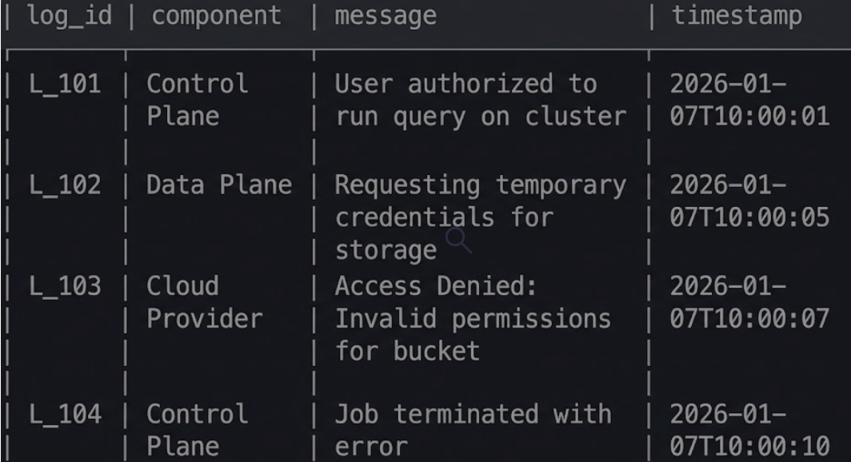
Based on the Databricks architecture and the logs provided, which statement best describes the component responsible for executing the query and the root cause of the failure?
- The Data Plane executes the query; failure is due to the Databricks workspace being in a different region than the data.
- The Data Plane executes the query; failure is due to insufficient cloud IAM permissions on the customer's storage.
- The Control Plane executes the query; failure is due to the Unity Catalog service being unavailable.
- The Control Plane executes the query; failure is due to a bug in the Databricks notebook interface.
------------------------------------------------------------------------------------------------------------------------------------
Overall explanation:
The Databricks Intelligence Platform operates on a distinct control plane / data plane architecture.
- Control Plane: Managed by Databricks in its own cloud account. It handles workspace management, user authentication, job scheduling, notebook revision history, and the Unity Catalog metadata. It's the "brain" of the operation.
- Data Plane: Resides in the customer's cloud account (AWS, Azure, or GCP). This is where the actual data processing happens. It contains the compute resources (VMs, containers) that run Spark executors. Crucially, your data sits in your own cloud storage buckets, and the compute in the data plane must have the correct cloud permissions (IAM roles) to access it.
------------------------------------------------------------------------------------------------------------------------------------
Documentation Reference:
High Level Architecture
Correct Answer: (2)
Question 7:
A retail analytics team wants to enrich internal sales data with third-party historical weather and demographic datasets. Instead of building custom ingestion pipelines or exchanging files manually, they want to browse available external data products from verified providers and make them accessible through Databricks.
Which Databricks feature should the team use to discover and install these external data products?
- Lakeflow Spark Declarative Pipelines
- Partner Connect
- Lakehouse Federation
- Databricks Marketplace
------------------------------------------------------------------------------------------------------------------------------------
Overall explanation:
Old Way: You want weather data. You find a vendor. They send you an API key. You write a Python script to hit the API every hour. You handle rate limits. You parse JSON. You fix it when it breaks.
New Way (Marketplace): You go to the Marketplace. You click "Get Data". The table weather_provider.nyc_temps appears in your catalog. You query it.
Databricks Marketplace leverages Delta Sharing under the hood. Because Delta Sharing allows zero-copy sharing, vendors can update the weather data on their side, and you see the new rows instantly on your side. There is no "pipeline" to break.
Documentation
- Databricks - MARKETPLACE
- What is Databricks Marketplace?

Correct Answer: (4)

Question 8:
A data engineer is building a Silver-layer table using Lakeflow Spark Declarative Pipelines (formerly Delta Live Tables). The business requirements specify that:
- Records with a null value in the user_id column are considered critical failures and should stop the entire pipeline immediately to prevent data corruption.
- Records with a transaction_amount less than zero should be excluded from the target table, but the pipeline should continue processing the remaining valid records.
Which two constraint clauses correctly implement these requirements? Select all that apply.
- CONSTRAINT valid_amount EXPECT (transaction_amount >= 0)
- CONSTRAINT valid_amount EXPECT (transaction_amount >= 0) ON VIOLATION FAIL UPDATE
- CONSTRAINT valid_user EXPECT (user_id IS NOT NULL) ON VIOLATION FAIL UPDATE
- CONSTRAINT valid_user EXPECT (user_id IS NOT NULL) ON VIOLATION DROP ROW
- CONSTRAINT valid_amount EXPECT (transaction_amount >= 0) ON VIOLATION DROP ROW
------------------------------------------------------------------------------------------------------------------------------------
Overall explanation:
Expectations allow you to define data quality as code.
- ON VIOLATION FAIL UPDATE: Stops the pipeline (Critical).
- ON VIOLATION DROP ROW: Discards the row (Filter).
- Default (No clause): Keeps the row but logs it (Warning).
In a production Lakehouse, expectations act as quality gates. You use FAIL UPDATE for structural or identity issues (like primary keys) and DROP ROW for business logic noise (like outliers or malformed logs).
------------------------------------------------------------------------------------------------------------------------------------
Documentation Reference:
https://docs.databricks.com/en/delta-live-tables/expectations.html

Correct Answer: (3,5)

Question 9:
In Databricks SQL, CTAS (CREATE TABLE AS SELECT) statements are commonly used to create new tables from query results.
Which statement about CTAS is NOT correct?
- CTAS is an abbreviation for CREATE TABLE AS SELECT.
- When using CTAS, the target table is populated with data when it is created.
- CTAS derives the table schema from the output of the SELECT query.
- CTAS allows the table schema to be explicitly defined column by column by the user.
------------------------------------------------------------------------------------------------------------------------------------
Overall explanation:
Databricks documents CREATE TABLE ... AS query as creating a table from the result of a query. In this form, the schema comes from the query output; it is not manually declared column by column in the CTAS statement itself. (docs.databricks.com)
CTAS is commonly used to:
- Materialize query results
- Create derived tables
- Optimize query performance
- Transform data into new layouts
------------------------------------------------------------------------------------------------------------------------------------
Official Documentation
- Databricks SQL CTAS

Correct Answer: (4):

Question 10:
A company needs to bring data into Databricks from multiple external systems. The architecture team is comparing several patterns.
Which two scenarios are the strongest candidates for Lakeflow Connect rather than another Databricks capability?
- Ingesting from a supported SaaS or database source using a managed connector instead of writing extraction notebooks.
- Ingesting supported external data sources when the team wants a Databricks-managed connector experience for recurring loads.
- Reading a small CSV file once with a simple SQL command.
- Querying an external MySQL or PostgreSQL database directly from Databricks without copying the data.
- Continuously discovering new JSON files arriving in S3 with schema inference and schema evolution.
------------------------------------------------------------------------------------------------------------------------------------
Overall explanation:
Lakeflow Connect (part of Databricks Lakeflow) is a fully managed, scalable data ingestion service. Its primary job is to provide native, managed connectors to easily bring data from popular SaaS applications (like Salesforce, Workday, etc.) and operational databases (like MySQL, Postgres) into the Lakehouse on a recurring basis, without requiring users to write or maintain complex ETL pipeline code.
Instead of engineers writing custom Python/Spark notebooks to hit APIs, handle pagination, and manage failures, Lakeflow handles it natively out-of-the-box. Lakeflow Connect is built specifically for recurring (scheduled) incremental loads where Databricks manages the infrastructure, state, and connector updates behind the scenes.

------------------------------------------------------------------------------------------------------------------------------------
Documentation:
- Managed connectors in Lakeflow Connect
- What is Lakeflow Connect?
- Lakeflow Connect

Correct Answers: (1,2)

Question 11:
A business analyst wants to connect Tableau Desktop to a Databricks SQL warehouse without manually gathering connection details. The team wants a simplified workflow inside Databricks that helps launch or configure the partner application with the correct connection information.
Which Databricks feature provides this streamlined integration experience?
- Databricks Marketplace
- Partner Connect
- Lakehouse Federation
- System Tables
------------------------------------------------------------------------------------------------------------------------------------
Overall explanation
The Integration Triad:
- Marketplace: Get Data (Content).
Marketplace (the answer to Question 97) is for discovering and installing data products (datasets and models). You would go here to buy "Weather Data," not to configure your Tableau software connection.
- Federation: Query Databases (Storage).
Lakehouse Federation (the answer to Question 87) is for the inverse direction: it allows Databricks to reach out and query external databases (like Postgres). It is not a tool for helping external BI clients connect in to Databricks.
- Partner Connect: Connect Tools (Software).
Partner Connect is the UI experience used to connect a Databricks workspace to partner solutions, and the Tableau integration page explicitly says you can use Partner Connect to connect a compute resource or SQL warehouse with Tableau Desktop in just a few clicks, including downloading a connection file.
------------------------------------------------------------------------------------------------------------------------------------
Documentation Reference:
What is Databricks Partner Connect?
Connect Tableau and Databricks

Correct Answer: (2)
Question 12:
A team is building a streaming pipeline to ingest JSON events from Amazon S3. They want to use Auto Loader to benefit from automatic schema inference and incremental file discovery.
Which code block correctly initializes a streaming DataFrame using Auto Loader?
- spark.readStream.format("delta") .option("cloudFiles.format", "json") .option("cloudFiles.schemaLocation", "/tmp/schema_location") .load("s3://events/")
- spark.readStream.format("cloudFiles") .option("cloudFiles.format", "json") .option("cloudFiles.schemaLocation", "/tmp/schema_location") .load("s3://events/")
- spark.read.format("cloudFiles") .option("format", "json") .option("schemaLocation", "/tmp/schema_location") .load("s3://events/")
- spark.readStream.format("json") .option("cloudFiles", "true") .option("cloudFiles.schemaLocation", "/tmp/schema_location") .load("s3://events/")
------------------------------------------------------------------------------------------------------------------------------------
Overall explanation:
Auto Loader is initialized with spark.readStream.format("cloudFiles"), and the underlying file format is then specified with cloudFiles.format. Current Databricks documentation states that Auto Loader provides a Structured Streaming source called cloudFiles and that it incrementally processes new files as they arrive in cloud storage. It also supports JSON as an input format and tracks ingestion progress through checkpointed state. That makes the cloudFiles source the defining element that distinguishes a correct Auto Loader initialization from a plain file stream or a Delta stream.
------------------------------------------------------------------------------------------------------------------------------------
Documentation Reference:
What is Auto Loader?

Correct Answer: (2)

Question 13:
A data engineer is defining a scheduled job in a Declarative Automation Bundles configuration. The bundle already includes the bundle: block, and the engineer needs to add a job definition with tasks and a notebook task.
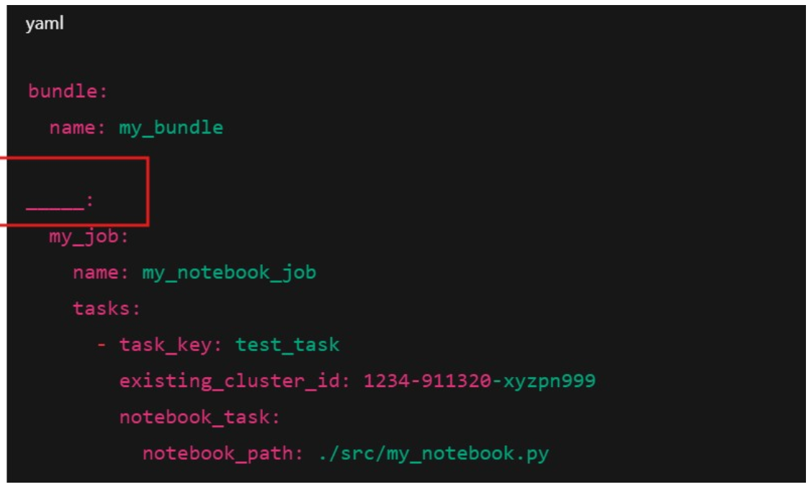
Which top-level YAML key must be used to define the job correctly?
- Resources
- Settings
- Workflows
- Pipelines
------------------------------------------------------------------------------------------------------------------------------------
Overall explanation:
Resources is the top-level mapping that contains deployable resource definitions, including jobs, pipelines, dashboards, clusters, and other workspace objects. The resources key is mandatory for defining deployable assets.
Declarative Asset Bundle is a packaging format that allows you to:
- Version control Databricks assets
- Deploy jobs, pipelines, and notebooks consistently
- Promote configurations across environments (dev → test → prod)
------------------------------------------------------------------------------------------------------------------------------------
Official Databricks Documentation
- Declarative Automation Bundles configuration

Correct Answer: (1)
Question 14:
A telecom operator uses Lakeflow Spark Declarative Pipelines to build a Silver table of call records. The Silver layer must enforce a data quality rule: records with a negative duration value must be excluded from the target dataset, while the pipeline must continue running.
Which Lakeflow Spark Declarative Pipelines expectation syntax correctly implements this requirement?
- @dp.expect("non_negative_duration", "duration >= 0")
- @dp.expect_or_drop("non_negative_duration", "duration >= 0")
- spark.read.table("bronze_cdr").filter("duration >= 0")
- @dp.expect_or_fail("non_negative_duration", "duration >= 0")
------------------------------------------------------------------------------------------------------------------------------------
Overall explanation:
Lakeflow Spark Declarative Pipelines (DLT) introduce expectations - declarative quality rules evaluated automatically across datasets. Unlike traditional WHERE clauses, expectations provide complete observability: pass/fail rates, violation samples, lineage integration.
Three actions available:
- expect_or_drop: Remove bad records, continue processing
- expect_or_fail: Stop pipeline on violations
- expect_or_warn: Log violations, continue
Important Notes about sintax:
@dp.expect_or_drop is the correct answer according to the current naming and recommended syntax.
@dlt.expect_or_drop may also work, but it reflects the legacy syntax.
------------------------------------------------------------------------------------------------------------------------------------
Documentation Reference:
Lakeflow Expectations

Correct Answer: (2)

Question 15:
A Lakeflow Jobs workflow runs nightly with three dependent tasks:
Task A → Task B → Task C
The run fails at Task B because of an out-of-memory error after Task A has already completed successfully. After increasing the compute resources for Task B, the data engineer wants to continue from the point of failure without rerunning Task A.
Which Lakeflow Jobs feature should be used?
- Clone the job and remove Task A
- Click Run now on the job
- Use Repair run after fixing the task configuration
- Manually run only Task B as a separate execution
------------------------------------------------------------------------------------------------------------------------------------
Overall explanation:
When a multi-task workflow fails after some upstream tasks already succeeded, the intended Databricks mechanism is Repair run. Databricks documents that repaired tasks are rerun as part of the original job run, which is exactly what is needed when the engineer wants to continue from the failed task rather than restart the whole workflow.
------------------------------------------------------------------------------------------------------------------------------------
Documentation Reference:
- Troubleshoot and repair job failures
- Repair a job run

Correct Answer: (3)

Question 16:
A data engineer is processing a "Silver" table that tracks the status of delivery packages. The system logs every status change. The requirement is to generate a report that shows only the final destination status for each package, but only for those packages that have already been "Delivered".
Initial Status (A):
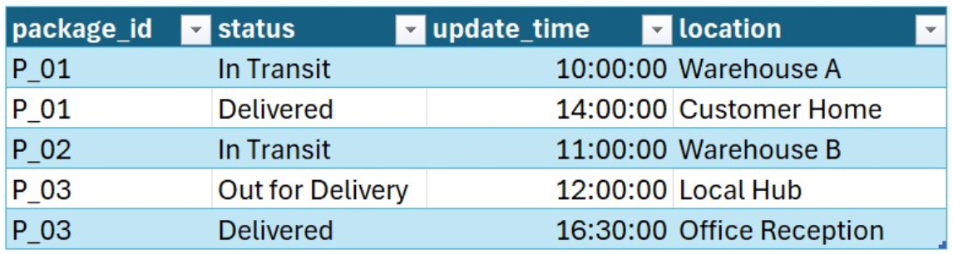
Final Status (B):
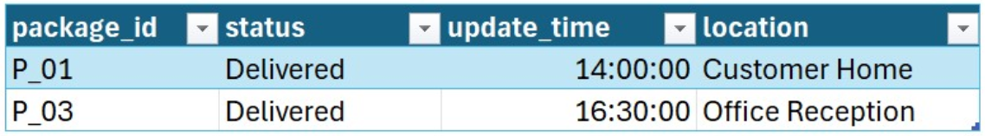
Which two operations were applied to Table A to produce the state in Table B? (Select two)
- A limit(2) clause was applied to the final DataFrame to match the required output size.
- A row_number() window function is created over partition by session_id order by login_time ASC.
- A groupBy("package_id") was performed using the first() aggregate function.
- A filter was applied to keep only rows where row_num = 1.
- The dropDuplicates(["package_id"]) method was used after sorting by update_time in asc order.
------------------------------------------------------------------------------------------------------------------------------------
Overall explanation:
- State Selection: Identifying the "Current" or "Final" state in a series of events (SCD Type 1 logic).
- Predicate Pushdown: Filtering out irrelevant data (like non-delivered packages) to reduce the volume of data processed in subsequent window functions.
------------------------------------------------------------------------------------------------------------------------------------Documentation:
Spark - Window Functions

Correct Answer: (2,4)

Question 17:
A data engineer needs to create a Unity Catalog dynamic view on top of gold.regional_sales with these rules:
- members of the admin_users account group can see all rows
- members of the us_users account group can see only rows where region = 'US'
- all other users should see no rows
Which SQL logic should be used in the WHERE clause of the dynamic view?
- WHERE region = current_user()
- GRANT SELECT ON gold.regional_sales TO us_users WHERE region = 'US'
- WHERE region IN (SELECT allowed_region FROM system.access.audit WHERE user = current_user())
- WHERE is_account_group_member('admin_users') OR (is_account_group_member('us_users') AND region = 'US')
------------------------------------------------------------------------------------------------------------------------------------
Overall explanation:
Row-Level Security (RLS): Restricting which rows a user can see based on who they are. Dynamic Views: A view where the WHERE clause includes functions that check the identity of the query runner at runtime.
Without Dynamic Views, you would have to create 50 separate views for 50 regions: view_us, view_eu, view_asia... and grant permissions separately. With a Dynamic View, you create one view view_global, and the view itself decides what to show.
- Admin looks at view_global -> Sees 100 rows.
- US User looks at view_global -> Sees 20 rows.
- When a new user joins the US team, you just add them to the us_users group in the Identity Provider (Azure Entra ID / AWS IAM). You do not need to modify any SQL code or Tables.
------------------------------------------------------------------------------------------------------------------------------------
Documentation Reference:
Create a dynamic view

Correct Answer: (4)

Question 18:
A Lakeflow Spark Declarative Pipelines pipeline cleans web logs in the Silver layer. The requirement is:
- records with user_id IS NULL must be excluded from the target dataset
- the pipeline must continue running
- the number of excluded records must be tracked in pipeline metrics
Which expectation syntax correctly implements this requirement
- @dp.expect_or_drop("valid_user_id", "user_id IS NOT NULL")
- spark.read.table("bronze_logs").filter("user_id IS NOT NULL")
- @dp.expect_or_fail("valid_user_id", "user_id IS NOT NULL")
- @dp.expect("valid_user_id", "user_id IS NOT NULL")
------------------------------------------------------------------------------------------------------------------------------------
Overall explanation
Lakeflow Spark Declarative Pipelines (the evolution of Delta Live Tables) introduce a declarative framework for building reliable data processing pipelines. A core component of this framework is Data Quality Expectations, which allow engineers to define constraints directly on datasets. These expectations prevent bad data from flowing into tables and provide visibility into data health. There are three primary modes of expectations:
- Expect (Warn): Records violating the rule are written to the target, but the violation is logged. This is useful for monitoring data drift without stopping processing.
- Expect or Drop: Records violating the rule are silently removed from the target dataset, and the drop count is logged. This is essential for "quarantine" logic or strict cleaning.
- Expect or Fail: The pipeline halts execution immediately if any record violates the rule. This is reserved for critical integrity checks where no data is better than bad data.
------------------------------------------------------------------------------------------------------------------------------------

Documentation Reference:
Expectations

Correct Answer: (1)
Question 19:
A data engineer is troubleshooting an "Access Denied" error reported by a data analyst (analyst_user). The analyst cannot query the table prod_catalog.marketing_schema.campaign_results, despite the security team claiming that the specific SELECT permission was granted.
To diagnose the issue, the engineer queries the information_schema.table_privileges view to see the effective table-level permissions. The results below confirm that the SELECT privilege exists for the user on the target table.
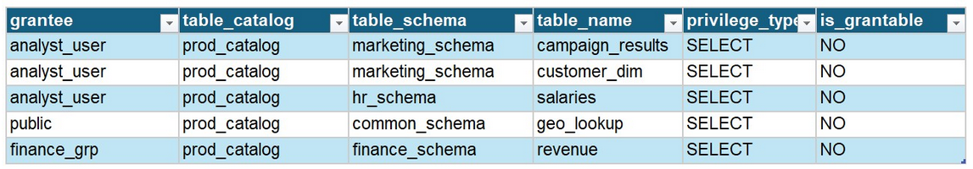
Despite the row confirming SELECT access, the query fails because Unity Catalog requires traversal permissions on the parent containers. Which two SQL commands must be executed to fully resolve this access issue? (Select two)
- GRANT USE SCHEMA ON SCHEMA prod_catalog.marketing_schema
- GRANT READ_METADATA ON TABLE prod_catalog.marketing_schema.campaign_results
- GRANT SELECT ON SCHEMA marketing_schema
- GRANT USE CATALOG ON CATALOG prod_catalog
------------------------------------------------------------------------------------------------------------------------------------
Overall explanation:
Unity Catalog enforces a Three-Level Namespace (Catalog.Schema.Table) with a hierarchical security model.
- Hierarchy: To access a leaf node (Table), you must have permissions on every node in the path above it.
- Traversal Permissions:
  - Catalog: Requires USE CATALOG.
  - Schema: Requires USE SCHEMA.
- Data Permissions:
  - Table: Requires SELECT.
------------------------------------------------------------------------------------------------------------------------------------
Documentation Reference: https://docs.databricks.com/en/data-governance/unity-catalog/manage-privileges/privileges.html#privilege-types
Correct Answer: (1,4)
Question 20:
A query joins a very large orders table with a much smaller customers table. In the Spark UI, most of the runtime is spent in shuffle-related stages, shuffle read is very large, tasks are skewed, and there is heavy spill.
Which Spark UI observation most directly shows that a broadcast join is not being used and that a shuffle-based join path was chosen instead?
- Large variance in task duration across executors
- High Spill (Disk) and Spill (Memory) metrics mean the root cause is insufficient executor memory, so increasing memory alone will fix the join
- High spill metrics in Exchange operator
- In the physical plan, the join path includes Exchange operators and there is no BroadcastExchange feeding a broadcast join node such as BroadcastHashJoin
------------------------------------------------------------------------------------------------------------------------------------
Overall explanation:
In Spark, a broadcast join is visible through nodes such as BroadcastExchange and BroadcastHashJoin. When those nodes are absent and the plan shows Exchange operators around the join path, Spark is using a shuffle-based strategy instead. Metrics such as skew, spill, and long task times are important, but they are downstream symptoms rather than the clearest direct indicator of whether broadcast was selected.
Join strategies:
- Broadcast Hash Join: Small table → all executors, hash lookup (optimal)
- Sort Merge Join: Both tables shuffle by join keys
- BroadcastNestedLoop: Small table × every large partition (disaster)
------------------------------------------------------------------------------------------------------------------------------------

Documentation Reference:
Spark UI Query Profile

Correct Anwser: (4)
Question 21:
A data engineer has a utility notebook config_setup containing shared variables and helper functions. They need to execute this utility from within another notebook so that the defined variables and functions become available in the current notebook’s scope.
Which command satisfies this requirement?
- dbutils.fs.head("./config_setup")
- import config_setup
- %run ./config_setup
- dbutils.notebook.run("./config_setup", 60)
------------------------------------------------------------------------------------------------------------------------------------
Overall explanation:
Notebook Modularity in Databricks is primarily handled through two distinct methods, each serving a different purpose in the development lifecycle:
- %run (Interactive Inclusion): Executes another notebook in the current scope. It is best used for setups, configuration definitions, and helper functions that need to be "inline" with the main code. It mimics a monolithic script split into files.
- dbutils.notebook.run (Orchestration): Executes another notebook as an isolated task. It passes data in via widgets/parameters and gets data out via exit values. It is best used for building pipelines where Task A runs, finishes, and then Task B runs independently.
In a collaborative data engineering environment, defining connection strings, file paths, and common UDFs (User Defined Functions) in every single notebook leads to code duplication and maintenance nightmares. The standard pattern is to create a common_libs or setup notebook.
- Use Case for %run: You are analyzing data interactively and need the standard path variables loaded.
- Use Case for dbutils.notebook.run: You are building a master pipeline controller that triggers ingest_sales, then ingest_inventory. You don't want variables from "sales" leaking into "inventory".
------------------------------------------------------------------------------------------------------------------------------------
Documentation Reference:
Orchestrate notebooks and modularize code in notebooks

Correct Answer: (3)
Question 22:
A data engineer is developing a Lakeflow Spark Declarative Pipelines pipeline and defines a logical view that exposes only a subset of rows from an existing table.
The pipeline includes this Python definition:
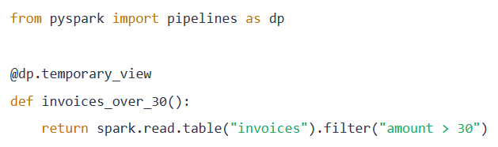
When the pipeline is deployed and executed, what kind of object does this definition create?
- A temporary Spark session view created only for the current notebook session.
- A temporary pipeline view whose results are computed when queried and used only inside the pipeline graph.
- A continuously updating streaming view.
- A materialized view stored as physical data.
------------------------------------------------------------------------------------------------------------------------------------
Overall explanation:
Databricks now recommends the pyspark.pipelines module, typically imported as dp, and the @temporary_view decorator. Databricks also explicitly notes that the older dlt module used @view for this purpose. The key behavior to test is that this creates a logical pipeline view whose results are evaluated when queried, not a materialized dataset and not a notebook-session temp view.
------------------------------------------------------------------------------------------------------------------------------------
Documentation:
- Databricks Temporary View
- CREATE TEMPORARY VIEW (pipelines)
- Lakeflow Spark Declarative Pipelines Best Practices

Correct Answer: (2)

Question 23:
A data engineer is designing a Lakeflow Jobs workflow with three tasks:
- Ingest_Source
- Transform_Data, which should run only if Ingest_Source succeeds
- Send_Failure_Alert, which should run only if Ingest_Source fails
How should the engineer configure the dependency condition for Send_Failure_Alert?
- Set the Run if condition to All succeeded.
- Use Repair run to trigger the alert after failure.
- Set the Run if condition to At least one failed.
- Remove the dependency and run Send_Failure_Alert independently.
------------------------------------------------------------------------------------------------------------------------------------
Overall explanation:
Conditional Execution (Branching) in Workflows: Standard DAGs are linear (A -> B -> C). Robust DAGs handle exceptions.
- Happy Path: A (Success) -> B.
- Failure Path: A (Fail) -> C (Alert).
Why use this instead of try...except in Python?
- Visibility: In the Jobs UI, you clearly see the "Alert" task turn Green or Grey. You can track how often alerts happen.
- Separation of Concerns: Your ingestion script (Ingest_Source) focuses on data. Your alert script (Send_Failure_Alert) focuses on Slack/PagerDuty integration. You don't mix the code.
------------------------------------------------------------------------------------------------------------------------------------
Documentation Reference:
- Databricks - Conditional Tasks
- Troubleshoot and repair job failures

Correct Answer: (3)
Question 24:
A data engineer is using Auto Loader to ingest a continuous stream of JSON files from cloud storage. The upstream application frequently adds new fields to the JSON payload.
The engineer wants Auto Loader to automatically record new columns in the schema and allow the pipeline to resume successfully after restart, without manually editing the schema definition.
Which Auto Loader option best matches this behavior?
- .option("cloudFiles.format", "delta")
- .option("mergeSchema", "true")
- .option("cloudFiles.schemaEvolutionMode", "addNewColumns")
- .option("spark.sql.streaming.schemaInference", "true")
------------------------------------------------------------------------------------------------------------------------------------
Overall explanation:
Schema Evolution is the ability of a pipeline to adapt to changing data structures.
- Rigid Pipeline: "I expect 3 columns. If I see 4, I crash."
- Adaptive Pipeline: "I see a 4th column? Cool, I'll add it to the table and keep going."
Auto Loader uses a Schema Location (a folder in DBFS/S3) to track the "known" schema. When it sees data that doesn't fit:
- Default: Fail (Safety).
- addNewColumns: Evolve (Agility).
- rescue: Put unknown data in a _rescue_data column (Safety + Continuity).
In modern agile development, producers (App Devs) often ship code faster than consumers (Data Engineers) can update pipelines. Using addNewColumns allows the Data Engineering team to stop being a bottleneck.
------------------------------------------------------------------------------------------------------------------------------------
Documentation Reference:
Configure schema inference and evolution in Auto Loader

Correct Answer: (3)

Question 25:
A data engineering team wants to improve its Databricks CI/CD process. They need a solution that:
- keeps code versioned in Git
- allows the same project to be promoted across dev, test, and prod
- supports environment-specific configuration without duplicating the codebase
- enables automated validation and deployment in pipelines
Which two actions best align with Databricks CI/CD best practices?
- Keep one completely separate copy of the project for each environment to avoid configuration conflicts
- Use Databricks Repos to create and switch branches, commit changes, and collaborate through Git-integrated development.
- Use Declarative Automation Bundles with environment-specific targets and overrides to deploy the same codebase across dev, test, and prod.
- Manually edit job settings in the Jobs UI after every deployment to adapt each environment.
- Store environment-specific cluster settings directly inside notebook code with conditional logic.
------------------------------------------------------------------------------------------------------------------------------------
Overall explanation:
The exam guide explicitly includes managing code development in the Databricks workspace UI with branches, commits, pushes, and pull requests through Databricks Git integration and using environment-specific configuration with Automation Bundle variables and overrides, and deploying Declarative Automation Bundles to promote the same codebase across dev, test, and prod.
------------------------------------------------------------------------------------------------------------------------------------
Documentation:
- CI/CD on Databricks
- Best practices and recommended CI/CD workflows on Databricks

Correct Answer: (2,3)
Question 26:
Analysts engineered a SQL step to clean subscription history into a final subscription view. The ‘Silver’ table tracks user plan changes. The engineered step identifies active subscriptions as of 2026-01-07 and keeps only users who have been on their current plan for more than 30 days.
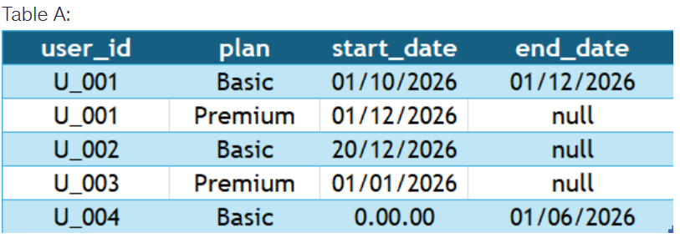
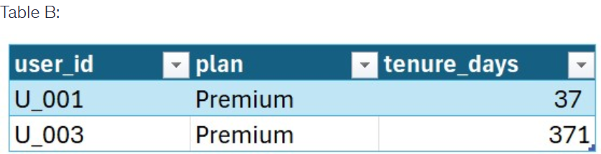
Which operations were applied to Table A to produce the state in Table B? (Select three)
- The coalesce() function was used to replace null values in end_date with the current date before filtering.
- A filter was applied to keep only records where end_date IS NULL.
- A filter WHERE tenure_days > 30 was applied to the calculated results.
- An inner join was performed on user_id to self-join the table and calculate the difference between plan cycles
- The datediff() function was used to calculate tenure_days between start_date and a literal date of '2026-01-07'.
------------------------------------------------------------------------------------------------------------------------------------
Overall explanation:
- SCD Type 2 Analysis: Tracking history over time. null in an end_date usually signifies the "current" active record.
- Date Arithmetic: Essential for business logic like "Loyalty," "Churn," or "Aging reports."
- Reference Dates: In production ETL, "Today" is often passed as a parameter to ensure the job is idempotent (produces the same result if re-run for that date).
------------------------------------------------------------------------------------------------------------------------------------
Documentation Reference: https://spark.apache.org/docs/latest/api/python/reference/pyspark.sql/api/pyspark.sql.functions.datediff.html

Correct Answer: (2,3,5)
Question 27:
A data engineer is refining a high-volume event stream. Due to a misconfiguration in the upstream message broker, some events are being sent multiple times, leading to duplicates in the silver_events table. The business requirement is to maintain a unique set of events based on the event_id, keeping only the most recent version of an event if multiple entries with the same ID exist (determined by the ingestion_timestamp).
The engineer is analyzing a subset of the data that needs to be cleaned:
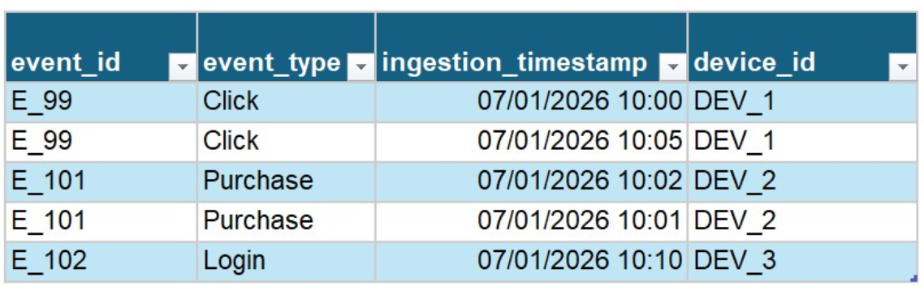
Which two methods are appropriate for removing these duplicates while ensuring the "most recent" record is preserved? (Select two)
- Use DISTINCT * in a SQL query to select all unique rows from the table.
- Execute a DELETE FROM silver_events WHERE event_id IN (SELECT event_id FROM duplicates_view).
- Enable ignoreChanges option in the read stream to automatically drop duplicate IDs at the source.
- Apply a window function row_number() partitioned by event_id and ordered by ingestion_timestamp DESC, then filter for row_number = 1
- Use the df.dropDuplicates(["event_id"]) method after sorting the DataFrame by ingestion_timestamp in descending order.
------------------------------------------------------------------------------------------------------------------------------------
Overall explanation:
Deduplication is the process of ensuring that a logical entity is represented only once in a dataset. In distributed systems, duplicates often occur due to "at-least-once" delivery semantics in messaging queues like Kafka.
- Simple Deduplication: Removing rows where all columns are identical (DISTINCT).
- Semantic Deduplication: Removing rows where a key is identical, but other columns (like timestamps) might differ, requiring logic to choose the "winner."
------------------------------------------------------------------------------------------------------------------------------------
Documentation Reference: https://docs.databricks.com/en/sql/language-manual/functions/row_number.html
Correct Answer: (4,5)
Question 28:
A Unity Catalog administrator has already created an external location named ext_finance_loc that points to a secure cloud storage path. A lead data engineer now needs to create a new external table whose data files will live inside this existing external location. The engineer does not need to create new external locations or manage storage credentials.
Which privilege must the administrator grant on the external location object?
- USE CREDENTIAL
- CREATE EXTERNAL TABLE
- CREATE EXTERNAL LOCATION
- READ FILES
------------------------------------------------------------------------------------------------------------------------------------
Overall explanation:
The Unity Catalog Hierarchy of Trust:
- Storage Credential (The Key): "I have the IAM Role." -> Privilege: CREATE EXTERNAL LOCATION.
- External Location (The Door): "I have opened the door to this bucket." -> Privilege: CREATE EXTERNAL TABLE or CREATE EXTERNAL VOLUME.
- Table/Volume (The Room): "I have put furniture (data) in the room." -> Privilege: SELECT or READ VOLUME.
The Administrator's goal is Least Privilege.
- If you give the engineer CREATE EXTERNAL LOCATION, they could map a random, unapproved bucket.
- By giving them CREATE EXTERNAL TABLE on only ext_finance_loc, you constrain them to putting data only where you (the Admin) have prepared the ground.
------------------------------------------------------------------------------------------------------------------------------------
Documentation Reference:
Databricks EXTERNAL Tables

Correct Answer: (2)
Question 29:
A data engineer has created a multi-task Lakeflow Jobs workflow with two notebook tasks:
- Calculate_Metrics, which computes a KPI value
- Send_Slack_Alert, which must use that KPI value in its message
The engineer wants to pass a small value directly between tasks without writing intermediate files.
Which Databricks utility should be used?
- spark.conf.set()
- dbutils.widgets
- dbutils.jobs.taskValues
- os.environ
------------------------------------------------------------------------------------------------------------------------------------
Overall explanation:
Databricks documents dbutils.jobs.taskValues as the utility for passing arbitrary values between tasks in a Databricks job. A task can set a key-value pair with dbutils.jobs.taskValues.set(), and downstream tasks can reference that value. Databricks also recommends referencing task values through dynamic value references in task parameters.
Widgets are used to accept input parameters into a notebook from the user or the Job definition. They are not designed for an upstream task to dynamically output values to a downstream task during execution.
------------------------------------------------------------------------------------------------------------------------------------
Documentation
Use task values to pass information between tasks
Databricks - utils

Correct Answer: (3)
Question 30:
A fintech company uses Unity Catalog. In the silver schema:
- the analytics group must be able to read tables
- the data_scientists group must be able to read tables and create new tables in silver
- they must not receive MODIFY privileges
Which SQL command correctly grants the additional permissions needed for data_scientists?
- GRANT USE SCHEMA, SELECT, CREATE TABLE ON SCHEMA silver TO `data_scientists`;
- GRANT MODIFYON SCHEMA silver TO `data_scientists`;
- GRANT ALL PRIVILEGES ON SCHEMA silver TO analytics;
- GRANT SELECT ON CATALOG sales_data TO analysts, data_scientists;
------------------------------------------------------------------------------------------------------------------------------------
Overall explanation:
Databricks currently documents that on a schema, CREATE TABLE allows creating tables or views, USE SCHEMA is required to interact with objects inside the schema, and SELECT granted at the schema level is inherited by current and future tables in that schema. Because the requirement explicitly excludes write access, MODIFY must not be granted. Therefore the correct schema-level combination for data_scientists is USE SCHEMA, SELECT, and CREATE TABLE, and not MODIFY or ALL PRIVILEGES.
Databricks documents that CREATE TABLE on a schema allows a principal to create tables or views in that schema. Databricks also documents that SELECT can be granted at the schema level and is inherited by current and future tables in that schema, while USE SCHEMA is required to interact with objects inside the schema. This grants read plus create capability without granting MODIFY.
------------------------------------------------------------------------------------------------------------------------------------
Documentation
- Databricks (AWS) – Manage Privileges in Unity Ctalog

Correct Answer: (1)
Question 31:
A retail firm ingests JSON sales logs from cloud storage into Delta Lake using Auto Loader. It then builds Silver tables for cleansing and standardization, and Gold tables for downstream analytics and ML-oriented outputs.
Which transformations are typically performed when building the Bronze layer?
- Land the data with minimal or no transformations.
- Build fully curated aggregates, KPI tables, and pre-aggregated outputs for downstream analytics.
- Perform extensive data cleansing and validation
- Apply business rules and complex transformation
------------------------------------------------------------------------------------------------------------------------------------
Overall explanation
Medallion architecture: bronze (raw, immutable), silver (clean, enriched), gold (aggregated, business-ready). Bronze transformations minimal: schema enforcement on read, add metadata columns (e.g., load_ts = current_timestamp()), partition by date/hour. Delta Lake ACID ensures no overwrites. Lakeflow @dlt.table auto-handles with infer_schema. Spark structured streaming/Auto Loader for incremental JSON/parquet. Key: no filtering/deduplication—retain all for audits.​
------------------------------------------------------------------------------------------------------------------------------------
Documentation
What is Medallion Architecture?

Correct Answer: (1)
Question 32:
A data engineer is building a real-time attribution pipeline that joins two streaming Delta sources: stream_impressions and stream_clicks. A click can arrive up to 2 hours after the matching impression. The join state keeps growing and causes memory pressure.
Which Structured Streaming function should be applied to the event-time columns to let Spark bound state and safely discard old unmatched records?
- .checkpoint("dbfs:/checkpoints/attribution")
- .withWatermark("event_time", "2 hours")
- .trigger(processingTime="2 hours")
- .repartition(200)
------------------------------------------------------------------------------------------------------------------------------------
Overall explanation:
Watermarking is the mechanism in Structured Streaming to handle late data and limit state size. By defining a watermark (e.g., "accept data up to 2 hours late"), you give the engine permission to drop any old data from the state store that is older than current_time - 2 hours. Without this, Spark must keep every impression in memory forever just in case a click arrives 10 years from now, inevitably crashing the cluster.
Stateful Streaming: When Stream A joins Stream B, Spark needs to remember Stream A's rows in case Stream B's matching row arrives later. Watermark: A "Deadline". Spark says: "If I haven't seen the Click by (Impression Time + 2 Hours), I assume it's never coming. I will delete the Impression from memory."
------------------------------------------------------------------------------------------------------------------------------------
Documentation Reference:
Structured Streaming Programming Guide

Correct Answer: (2)
Question 33:
A multi-tenant e-commerce platform processes large-scale data across multiple Unity Catalog-enabled workspaces. External partners need read-only access to aggregated sales summary tables for joint forecasting. The company must share the data without copying or moving it, and the sharing mechanism must work across clouds while preserving governance.
Which approach best enables governed data sharing with external recipients?
- Create external tables over shared object storage paths that partners access directly.
- Export the data to CSV files and share them through signed cloud storage URLs.
- Use Delta Sharing to provide recipients a secure share for querying Delta tables without data copying.
- Replicate the tables into partner workspaces using pipelines and then grant access there.
------------------------------------------------------------------------------------------------------------------------------------
Overall explanation:
Unity Catalog's Delta Sharing enables secure, protocol-based data exchange without copying files. Providers create shares (logical groupings of tables/views) and grants recipient privileges like SELECT. Recipients authenticate via tokens to query via JDBC/ODBC or Databricks clients. Key advantages: zero-ETL overhead, cross-cloud/platform compatibility (AWS/Azure/GCP), inherited governance (tags, lineage, auditing). Limitations: read-only, requires compatible clients (e.g., Delta-RS), no direct table modifications, potential query costs on recipient side. Lakehouse Federation complements by querying external sources in-place, but sharing focuses outbound.​
Databricks documents Delta Sharing as an open protocol for secure data sharing with other organizations regardless of which computing platforms they use. Databricks also documents that shares are read-only collections of tables and partitions, and that open sharing can be used with any recipient using any tool. This directly matches the requirement for governed, cross-cloud, read-only sharing without copying data. (docs.databricks.com)
------------------------------------------------------------------------------------------------------------------------------------
Documentation
- Databricks - Delta Sharing
- Access data shared with you using Delta Sharing (for recipients)
- Read data shared using Delta Sharing open sharing with bearer tokens (for recipients)

Correct Answer: (3)
Question 34:
A Data Engineer is building a Delta Lake table that ingests clickstream events continuously while analysts run dashboards against the same table. The team has a strict requirement that partially written batches must never be visible, and that reads must remain correct even when multiple writers are updating partitions at the same time.
Which benefits of ACID transactions in Delta Lake directly address these requirements? (Choose two.)
- They automatically compact small Parquet files into larger files.
- They speed up queries by automatically enabling Delta caching.
- They provide transactional isolation/consistency so concurrent reads and writes remain correct.
- They guarantee atomic commits, so writes are fully applied or fully reverted.
- They eliminate the need for schema enforcement.
------------------------------------------------------------------------------------------------------------------------------------
Overall explanation:
ACID in Delta Lake is implemented via the Delta transaction log (the _delta_log). Each transaction records a new version of the table by writing a commit entry that atomically defines which data files are added/removed. Readers query a consistent snapshot (a specific table version), and writers use optimistic concurrency control to detect conflicts.
ACID Stands for:
- Atomicity
A transaction is treated as a single, indivisible unit.
Either all its operations succeed, or none of them do.
- Consistency
A transaction must take the database from one valid state to another valid state.
No transaction can violate database rules or constraints.
- Isolation
Multiple transactions happening at the same time must not interfere with each other.
Each transaction behaves as if it were the only one running.
- Durability
Once a transaction is committed, the result is permanent—even if there is a crash, power failure, or system error.
------------------------------------------------------------------------------------------------------------------------------------
Documentation:
- Delta Lake: Transaction log and ACID guarantees
- Delta Lake: What is Delta Lake
Correct Answer: (3,4)
Question 35:
A data engineer must choose between Auto Loader and the COPY INTO command for incremental file loading.
In which scenario should the data engineer choose Auto Loader over the COPY INTO command?
- When performing a one-time historical backfill with a stable schema.
- When loading a small, static set of files from cloud storage using a simple SQL batch load.
- When the source schema is expected to evolve over time and the pipeline should automatically handle new columns.
- When the environment cannot persist Structured Streaming checkpoints.
------------------------------------------------------------------------------------------------------------------------------------
Overall explanation:
Auto Loader is superior in scenarios that require automatic schema inference/evolution or when processing directories containing millions of files.
Why Auto Loader is the correct choice in these scenarios:
- Schema Evolution: Auto Loader can detect the addition of new columns in the source files and automatically update the schema or rescue data into a _rescued_data column. COPY INTO requires a predefined, static schema.
- File Discovery Scaling: For directories with millions of files, COPY INTO becomes slow because it must list all files in the directory to check for new ones. Auto Loader's File Notification mode (using AWS SNS/SQS or Azure Event Grid) discovers new files as they arrive without expensive listing operations.
- Structured Streaming Integration: Auto Loader is built as a Spark Structured Streaming source, allowing for lower latency and tighter integration with writeStream checkpoints.
------------------------------------------------------------------------------------------------------------------------------------
Documentation
- What is Auto Loader? (docs.databricks.com)
- Configure schema inference and evolution in Auto Loader. (docs.databricks.com)
- COPY INTO language reference. (docs.databricks.com)

Correct Answer: (3)
Question 36:
A Databricks platform administrator wants to reduce classic compute costs by using cloud provider spot or preemptible instances. These instances can be reclaimed by the cloud provider at any time.
Which workload type is the most appropriate candidate for running on spot instances?
- High-throughput transactional systems requiring constant availability.
- Ad-hoc exploratory analysis performed interactively by analysts.
- Continuous streaming applications with strict latency guarantees.
- Batch-oriented jobs that can tolerate interruptions and be retried.
------------------------------------------------------------------------------------------------------------------------------------Overall explanation:
Spot (or preemptible) instances are:
- Excess cloud compute capacity
- Offered at a significant discount
- Can be terminated at any time by the provider
How Databricks Uses Spot Instances:
- Automatically replaces terminated executors
- Retries failed Spark tasks
- Integrates with cluster autoscaling
------------------------------------------------------------------------------------------------------------------------------------
Databricks Documentation
- Best practices for cost optimization
- Compute creation cheat sheet

Correct Answer: (4)
Question 37:
A junior data engineer is building a Silver dataset with Lakeflow Spark Declarative Pipelines. The source data contains some records where transaction_total is negative. The business requirement is:
- records with negative transaction_total must not be written to the target dataset
- valid records must continue processing normally
- the pipeline must remain operational instead of failing on invalid rows
Which syntax correctly implements this requirement?
- @dp.expect_or_drop("valid_total", "transaction_total >= 0")
- spark.read.table("bronze_transactions").filter("transaction_total >= 0")
- @dp.expect("valid_total", "transaction_total >= 0")
- @dp.expect_or_fail("valid_total", "transaction_total >= 0")
------------------------------------------------------------------------------------------------------------------------------------
Overall explanation:
Data quality management in modern Lakehouse architectures relies on declarative expectations. Rather than writing complex imperative logic (e.g., if/else blocks or filter transformations) to validate data, engineers declare rules directly on the dataset definition. In Lakeflow Spark Declarative Pipelines, these expectations are categorized by their severity:
- Retain: Record violation, warn in logs (expect).
- Drop: Remove violating row, continue processing (expect_or_drop).
- Halt: Stop pipeline execution immediately (expect_or_fail).
------------------------------------------------------------------------------------------------------------------------------------
Documentation Reference:
Expectations

Correct Answer: (1)
Question 38:
A team needs to join historical sales data in Delta Lake with real-time support tickets stored in an external PostgreSQL database. To avoid building a new ETL pipeline, they want to query the PostgreSQL data directly from Databricks while managing access through Unity Catalog.
Which Databricks capability should the team use?
- Partner Connect
- Databricks Marketplace
- Lakeflow Spark Declarative Pipelines
- Lakehouse Federation
------------------------------------------------------------------------------------------------------------------------------------
Overall explanation:
Databricks documents Lakehouse Federation as the query federation platform for user data governed by Unity Catalog. It lets users take actions on data in external systems from Databricks, including querying those sources in place instead of moving the data. Databricks also documents support for external sources such as PostgreSQL. (docs.databricks.com)
Lakehouse Federation solves the "Data Silo" problem without the "Data Integration" headache.
- Traditional ETL: Copy data from System A to System B. (Slow, duplicates data, stale).
- Federation: System B simply "looks at" System A. (Fast setup, real-time, no copy).
------------------------------------------------------------------------------------------------------------------------------------
Documentation Reference:
- What is Lakehouse Federation?
- Run federated queries on PostgreSQL

Correct Answer: (4)
Question 39:
A data architect wants to drop the legacy_code column from gold.products. Before running the schema change, they need to identify every downstream notebook, dashboard, job, or table that references that specific column.
Which Unity Catalog system table should be queried to retrieve column-level lineage information?
- system.information_schema.columns
- system.lineage.table_lineage
- system.lineage.column_lineage
- system.access.audit
------------------------------------------------------------------------------------------------------------------------------------
Overall explanation:
Databricks documents system.lineage.column_lineage as the system table that stores column-level lineage records, including source and target columns for lineage events. That is the right table for impact analysis when the change concerns a specific column rather than only a table-level dependency. (docs.databricks.com)
Data Lineage answers the question: "Where did this data come from, and where does it go?"
- Table Lineage: High-level map. "The 'Sales' dashboard reads from the 'Gold' table."
- Column Lineage: High-precision map. "The 'Total Revenue' widget reads from the 'Amount' column."
------------------------------------------------------------------------------------------------------------------------------------
Documentation Reference:
- Lineage system tables
- System tables reference
- Audit log system table reference

Correct Answer: (3)
Question 40:
A data engineer manages a very large Delta table with the following problems:
- partition skew, where some partitions are very large and others are nearly empty
- write conflicts caused by concurrent updates to the same partitions
- heavy maintenance overhead from repartitioning and repeated OPTIMIZE ZORDER BY operations
- query patterns that change over time across different filter columns
Which Delta Lake feature best addresses these issues with a more flexible and incremental data layout strategy?
- Bloom Filter Indexes
- Liquid Clustering (CLUSTER BY)
- Generated Columns
- Change Data Feed
------------------------------------------------------------------------------------------------------------------------------------
Overall explanation:.
- Liquid Clustering: The modern "Smart" layout. It replaces both Partitioning and Z-Ordering. It clusters data dynamically as it is written.
Liquid Clustering is the next-generation layout optimization for Delta Lake. Unlike Hive-style partitioning (which physically separates data into directories) or Z-Ordering (which requires expensive full rewrites), Liquid Clustering:
- Incremental: It optimizes data incrementally without rewriting the whole table.
- Flexible: You can change the clustering keys (CLUSTER BY) at any time without rewriting existing data.
- Skew-Resistant: It handles uneven data distribution automatically, avoiding the "small file" or "giant partition" problems of directory-based partitioning.
- Concurrency: It reduces write conflicts because it doesn't lock at the partition level.
------------------------------------------------------------------------------------------------------------------------------------
Documentation Reference:
Use liquid clustering for tables

Correct Answer: (2)
Question 41:
A data engineer is refining a "Silver" table that tracks user login sessions. The source data contains duplicates due to a retry logic error in the mobile app, where multiple logs are sometimes sent for the same session_id. The engineer needs to keep only the first occurrence of each session based on the login_time.
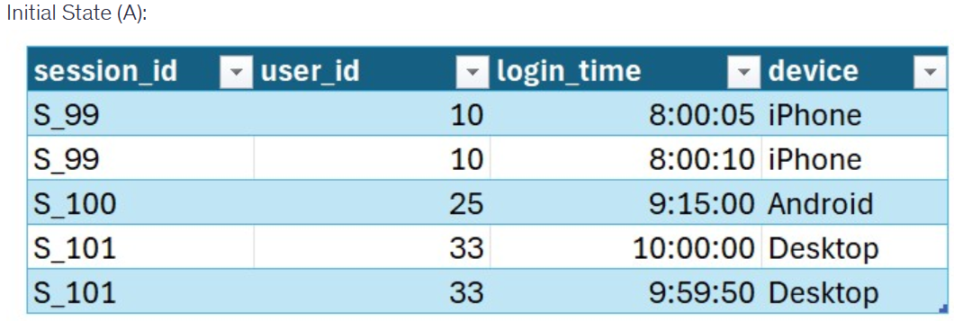
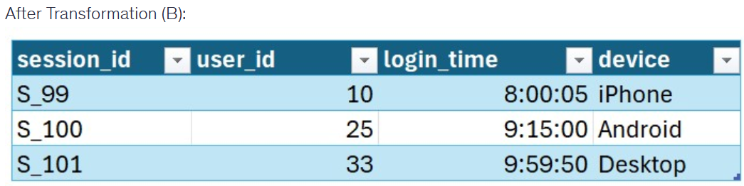
Which two operations were applied to Table A to produce the deduplicated state in Table B? (Select two)
- A window function row_number() was created, partitioned by session_id.
- A groupBy("session_id") was used with a max("login_time") aggregation.
- The window was ordered by login_time in descending (DESC) order.
- A dropDuplicates(["user_id"]) operation was performed to ensure one record per user.
- The window was ordered by login_time in ascending (ASC) order.
------------------------------------------------------------------------------------------------------------------------------------
Overall explanation:
Fundamental Concepts
- Deduplication with Context: Unlike a simple DISTINCT, window-based deduplication allows you to define a "Key" (session_id) and a "Preference" (earliest time) while maintaining all columns.
- Window Spec: In Spark, this consists of partitionBy (to define the groups) and orderBy (to define the ranking logic).
------------------------------------------------------------------------------------------------------------------------------------
Documentation Reference:
Apache Spark Window Documentation

Correct Answer: (1,5)
Question 42:
A data engineer is configuring an Auto Loader (Cloud Files) stream to ingest JSON log files from a cloud storage bucket into a Delta table. The schema of the source files is expected to evolve over time. Specifically, upstream systems may start sending new fields (columns) without prior notice. The requirement is that the pipeline must automatically update the Delta table schema to include these new columns as they appear, without causing the stream to fail or requiring a restart.
The engineer observes the following sequence of files arriving in the landing zone:
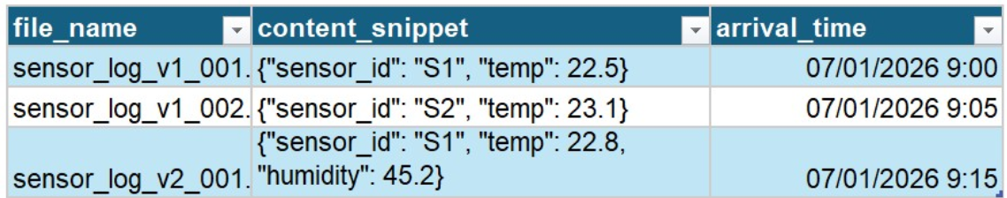
Which configuration option must be added to the .option() settings of the spark.readStream.format("cloudFiles") command to satisfy this requirement?
- .option("mergeSchema", "true")
- .option("cloudFiles.schemaEvolutionMode", "rescue")
- .option("cloudFiles.schemaEvolutionMode", "addNewColumns")
- .option("cloudFiles.inferColumnTypes", "true")
------------------------------------------------------------------------------------------------------------------------------------
Overall explanation:
Auto Loader (Cloud Files) is the primary mechanism in Databricks for efficiently ingesting raw files from cloud storage (S3, ADLS, GCS). A key feature of Auto Loader is Schema Evolution. Unlike traditional ETL where schemas are rigid, Auto Loader can adapt to drifting data. It maintains a schema location (directory) to track the state of the schema and uses specific modes to determine how to handle unexpected fields:
- addNewColumns: The "evolving" mode. New fields become new columns.
- rescue: The "safe" mode. Unexpected fields go into _rescued_data.
- failOnNewColumns: The "strict" mode. The stream stops.
------------------------------------------------------------------------------------------------------------------------------------
Documentation Reference:
Databricks - Schema Evolution

Correct Answer: (3)
Question 43:
A fintech company runs a mixed workload on Databricks:
- scheduled ETL pipelines using Lakeflow Jobs
- nightly ML training jobs
- ad hoc BI queries during market hours
- some collaborative notebook-based exploration
The team wants to reduce cost from overprovisioned all-purpose compute while still meeting SLA and responsiveness requirements.
Which compute strategy is the best fit?
- Use spot instances exclusively for all jobs to minimize cost.
- Use serverless compute for Lakeflow Jobs, use SQL warehouses for BI, use ephemeral job compute for ML training, and reserve all-purpose compute only for collaborative notebook work.
- Consolidate all workloads on shared all-purpose compute.
- Migrate every workload to autoscaling all-purpose compute.
------------------------------------------------------------------------------------------------------------------------------------
Overall explanation:
Serverless compute is now the primary recommended option when the workload is supported, and for Lakeflow Jobs, serverless compute is the default for supported task types and Databricks recommends using serverless compute for all job tasks.
For BI and ad hoc SQL, Databricks SQL with SQL warehouses remains the recommended engine, and serverless SQL warehouses are recommended for most workloads. Classic all-purpose compute still has a role, but mainly for interactive collaborative notebook work or cases where serverless is not supported. The best answer is therefore a mixed compute strategy aligned to workload type, not a single cluster model for everything.
------------------------------------------------------------------------------------------------------------------------------------
Documentation Reference:
- Run your Lakeflow Jobs with serverless compute for workflows
- Configure compute for jobs
- Compute configuration recommendations

Correct Answer: (2)
Question 44:
A company is ingesting millions of small CSV files from an Azure Data Lake Storage (ADLS) Gen2 container. The files arrive unpredictably throughout the day. The data engineer needs an ingestion strategy that:
- Provides idempotency (ensures no file is processed twice).
- Scales efficiently without the overhead of listing millions of files in the directory during every trigger.
- Automatically infers the schema and handles potential new columns without manual table updates.
Which two technologies or features are most appropriate for this scenario? (Select two)
- Auto Loader with Schema Inference and Evolution enabled.
- Auto Loader with File Notification mode.
- The COPY INTO SQL command with a WHERE clause for timestamps.
- A daily Python job that uses dbutils.fs.ls() to find new files.
------------------------------------------------------------------------------------------------------------------------------------
Overall explanation:
Auto Loader is unique because it can automatically detect the schema of incoming CSV files. If a new column is added to the source CSVs later, the cloudFiles.schemaEvolutionMode allows the target Delta table to be updated automatically. It also includes a _rescued_data column to catch data that doesn't match the schema, ensuring no data loss during ingestion—a key requirement for "unpredictable" file arrivals.
When dealing with millions of files, the standard "Directory Listing" (asking the storage "give me a list of all files") becomes extremely slow and expensive. Auto Loader's File Notification mode integrates with cloud services (like Azure Grid/Queue) to listen for new file arrivals. This allows the engine to skip the listing process entirely and only process files it knows are new. This is the only way to scale ingestion efficiently for the volume described.
- Idempotency: Processing the same input twice yields the same result.
- Directory Listing vs. Notifications: Notifications are "Push" (fast for millions of files); Listing is "Pull" (slow for millions of files).
------------------------------------------------------------------------------------------------------------------------------------
Documentation Reference:
https://docs.databricks.com/en/ingestion/auto-loader/index.html

Correct Answer: (1,2)
Question 45:
A data engineer needs to build a Structured Streaming pipeline in PySpark to continuously ingest event data from Apache Kafka.
Which code block correctly creates a streaming DataFrame that consumes data from a Kafka topic?
- df = spark.readStream.kafka(host_port, events_topic, "latest")
- df = (spark.readStream.format("kafka").option("kafka.bootstrap.servers", host_port).option("subscribe",events_topic).option("startingOffsets", "latest").load())
- df = (spark.readStream.format("cloudFiles").option("cloudFiles.format", "kafka").option("cloudFiles.subscribe", "events_topic").option("cloudFiles.bootstrap.servers", broker).option("startingOffsets", "latest").load())
- df = spark.readStream.format("kafka").load(host_port,events_topic,"latest")
------------------------------------------------------------------------------------------------------------------------------------
Overall explanation
Apache Kafka is a distributed event streaming platform commonly used for:
- Event ingestion
- Log aggregation
- Real-time analytics
In Databricks and Spark, Kafka is integrated via Structured Streaming.
Required Kafka Options:
OptionPurposekafka.bootstrap.serversKafka broker addressessubscribeTopic name(s)startingOffsetsWhere to start reading (earliest / latest)
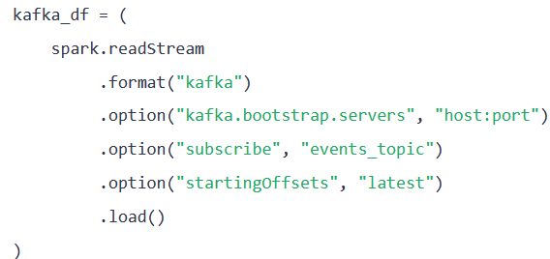
------------------------------------------------------------------------------------------------------------------------------------
Official Documentation
- Connect to Apache Kafka
- Kafka Options
Correct Answer: (2)

